North Wells Street Historic District
U.S. National Register of Historic Places
U.S. Historic district
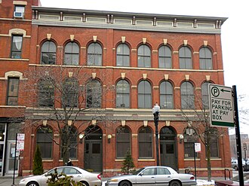
Engine Company No. 27
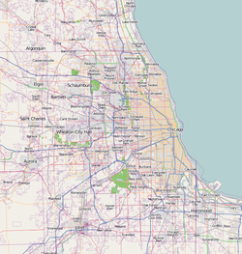
Show map of Chicago metropolitan areaShow map of IllinoisShow map of the United StatesShow all
Location | 1240-1260 N. Wells St., Chicago, Illinois
Coordinates | 41°54′20″N 87°38′5″W
Area | less than one acre
Built | 1871
Architectural style | Italianate, Queen Anne
NRHP reference No. | 84001021^{[1]}
Added to NRHP | May 3, 1984

